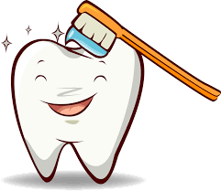
FREE Dental Screenings

When
Thursday March 10th 5-7PM
Tuesday March 22nd 5-7PM
Thursday April 7th 5-7PM
Thursday April 22nd 5-7PM
Where
State Fair Dental Hygiene clinic located in the Fred E. Davis Multipurpose Center

State Fair Dental Hygiene students are currently looking for qualifying clinical exam patients to complete a dental cleaning to obtain state licensure

What we are looking for
- Patients that have not had a dental cleaning in 3+ years
- Patients that would be available in April 2022 to travel to either Joplin or Kansas City, Missouri for the clinical exam
Qualifying patients that agree to attend the exam will receive up to $1,000 worth of FREE dental care. All travel expenses will be paid by the dental hygiene student, and you will receive a FREE Oral-B electric toothbrush.
Contact
For Additional questions contact the clinic at
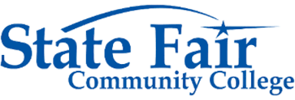
660-596-7309

